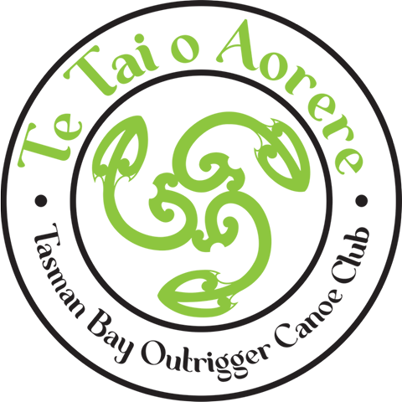

Hoe Matariki
Tahunanui Beach
Nelson
Te Tai o Aorere - Tasman Bay Outrigger Canoe Club invite waka whanau to celebrate Matariki in the beautiful waters of the Nelson Haven & Tasman Bay.

Friday June 24th.
OC1 and OC2 Fifeshire relay 10km*
*each competitor will do 2 x 2.5km laps
OC1: 2 Paddlers / OC2: 4 Paddlers
Tamariki/Rangatahi/Novice W6 5km

Saturday June 25th
Tahunanui Beach/Oyster Island W6 18km Men, Women and Mixed
OC1 & OC2 18km and Surf ski option also

Online entries via WANZ – please register with your club rep.
https://www.wakaama.co.nz/racecalendar/lookup/2012
Entries close midday Thursday 16 June
Roster close midnight Monday 20 June

Tamariki: Taitamariki & Intermediate
Rangatahi: J16 & J19
Adults: Open, Master, Snr Master, Gldn Master, Master 70

Tamariki free Rangatahi $5 Adults* $30 – *one fee for as many events as you like
Once entered payment can be made online - If you require an invoice/receipt we will be happy to issue one.

Te Tai o Aorere
NBS 03 1354 0557388 00
Club and team name for reference please

In these covid times masks will be encouraged at the event and if you are unwell, please stay away.

PFDs will be compulsory and worn by all competitors.

Prizegiving to follow at the conclusion of each day’s racing –
venue tbc (weather dependant)

WANZ Race rules apply.
Tamariki and Rangatahi may have 2 experienced paddler/Steerers
Novice may have an experienced steerer.

We will provide a warm soup or chowder following your event (included in your race fee)

An evening get together on the Saturday will be organised at a venue close by for those wanting to socialise.

Panui #2 will include
Trailer parking and waka drop off
Event schedule – briefing and race start times
An event and race course maps
Directions to the best coffee shop in town!

All enquiries to
Carmel Barrett
Race Director: tasmanbayocc@gmail.com 0276668493

